PROJECT PROPOSAL
Smart Campus Entry Monitoring &
Biometric Access Control System
Real-Time LAN-Based Fingerprint Monitoring for 10,000+ Students

Submitted By | Sanket Mali
Roll No / Batch | E265 / B.Tech Computer Science — 2023–2027
Institution | SVKM's NMIMS MPSTME, Shirpur
Submitted To | College Administration
Date of Submission | 11 April 2026
Under the Guidance of | Dr. Nitin Choubey

1. Executive Summary
This proposal presents the Smart Campus Entry Monitoring and Biometric Access Control System — a production-grade, full-stack platform designed to completely replace manual gate registers at SVKM's NMIMS MPSTME, Shirpur with an automated, biometric-first, real-time monitoring infrastructure.

Unlike traditional attendance systems, this solution integrates biometric authentication with real-time access control, automated approval workflows, and live monitoring dashboards — accessible to administration, security staff, and parents from any device at any time.

"The system uses industry-grade biometric terminals instead of microcontroller-based solutions to ensure reliability, security, scalability, and compliance with data privacy standards."

The demo pilot covers one gate with two eSSL X990 industrial fingerprint terminals, a college server PC running the complete backend, and a publicly accessible React dashboard via Cloudflare Tunnel — fully operational with every feature active from day one.

2. Problem Statement
The current gate management at SVKM's NMIMS MPSTME, Shirpur relies entirely on manual processes. This creates the following critical operational, safety, and administrative gaps:

Problem Area | Current Situation | Impact
Gate Entry Records | Manual handwritten registers by security guard | Error-prone, easily falsified, no digital audit trail
Real-Time Tracking | No system to know who is currently inside campus | Administration blind to campus population at any moment
Hosteller Control | No enforced exit restriction for hostel students | Curfew violations undetected until next morning
Unauthorised Entry | Guard depends on visual recognition only | Unregistered individuals can enter without any alert
Parent Awareness | No notification system — parents never informed | Parents unaware of child's arrival or departure
Incident Investigation | Paper records only — incomplete and tamper-prone | Cannot reconstruct events reliably after an incident
Analytics | No data on peak hours, absenteeism, or gate traffic | Administration cannot make data-driven security decisions

These gaps collectively represent a significant security, accountability, and administrative risk that a modern institution of NMIMS's standing should not accept.

3. Proposed Solution
"A centralised system using biometric authentication, real-time monitoring, and automated approval workflows to manage student movement securely and efficiently."

The solution consists of three tightly integrated layers:

Layer | Component | Role
Hardware | eSSL X990 Biometric Terminals | Fingerprint capture and onboard matching at each gate
Backend | Node.js + MongoDB on College Server PC | All business logic, access control, notifications, logs
Frontend | React Dashboard via Cloudflare Tunnel | Live monitoring for admin, security, and parents

The system is built on the MERN stack (MongoDB, Express.js, React 18, Node.js) with Docker containerisation, Socket.io for real-time communication, Amazon SES for reliable email delivery.

4. System Requirements
The following hardware, software, and network requirements must be in place for successful deployment of the Smart Campus Entry Monitoring System. These requirements are designed to be minimal and practical — most components are either already available at the college or are low-cost additions.

4.1 Hardware Requirements
Component | Specification | Qty | Notes
Biometric Terminal (Gate) | eSSL X990 or equivalent — 10,000 FP capacity, ePush, TCP/IP, access control relay | 1 per gate lane | 2 recommended for main gate to avoid congestion
Biometric Terminal (Enrollment) | eSSL X990 — same model as gate terminals, placed in admin office | 1 | Used only during enrollment drive, then relocated to gate
Central Server PC | Intel i5, 16GB RAM, 512GB SSD, Ubuntu Server 22.04 LTS | 1 | Existing college PC can be used if specifications are met
Network Switch | Standard 8-port Gigabit switch (non-POE) | 1 per gate | TP-Link TL-SG108 or equivalent
LAN Cables (Cat6) | 10m per terminal to switch, 20m switch to server | As required | Wired connection strongly preferred over WiFi for reliability
Power Adapters (12V 2A) | One per terminal — independent power supply | 1 per terminal | Standard adapter, no special requirements
UPS (Gate) | 600VA minimum — protects gate switch and terminals | 1 per gate | Provides 30–45 minutes backup during power cuts
UPS (Server) | 1 KVA minimum — protects server PC | 1 | Mandatory — server downtime affects all gates
Main Gate Monitoring PC | Any PC — for Monitoring dashboard | 1 | Connected to any browser showing the Dahboard and logs

4.2 Software Requirements
Software | Purpose | Cost
Ubuntu Server 22.04 LTS | Operating system for college server PC | Free
Docker and Docker Compose | Containerises all services — single command deployment | Free
Node.js (Express.js) | Backend API server — handles all business logic | Free (open source)
React 18 (Vite) | Frontend dashboard — admin, security, public views | Free (open source)
MongoDB | Database — stores student profiles, logs, access control data | Free (open source)
Socket.io | Real-time communication — live dashboard updates without refresh | Free (open source)
Amazon SES | Reliable email delivery for parent notifications | ~₹1,000/month at scale
Cloudflare Tunnel | Secure public HTTPS access to dashboard — no IT config needed | Free
Git / GitHub | Version control — deploy code updates remotely via SSH | Free

4.3 Network Requirements
Requirement | Details | Importance
Same network subnet | All terminals, enrollment device, and server on same LAN | Mandatory — ZK protocol (port 4370) requires local network access
Static IP or DHCP reservation | Each terminal and server must have a fixed IP address | Mandatory — backend communicates to terminals by IP
Port 4370 open (LAN) | ZK communication protocol between server and terminals | Mandatory — template sync and user management use this port
Port 5000 open (LAN) | Backend API — terminals push scan events to this port | Mandatory — all gate scan events arrive here
Internet access (optional) | Required only for: parent email delivery, Cloudflare Tunnel public dashboard | Optional — gates and monitoring work without internet
WiFi (fallback only) | Terminals support WiFi — use only if ethernet cable not possible | Optional — wired ethernet strongly preferred

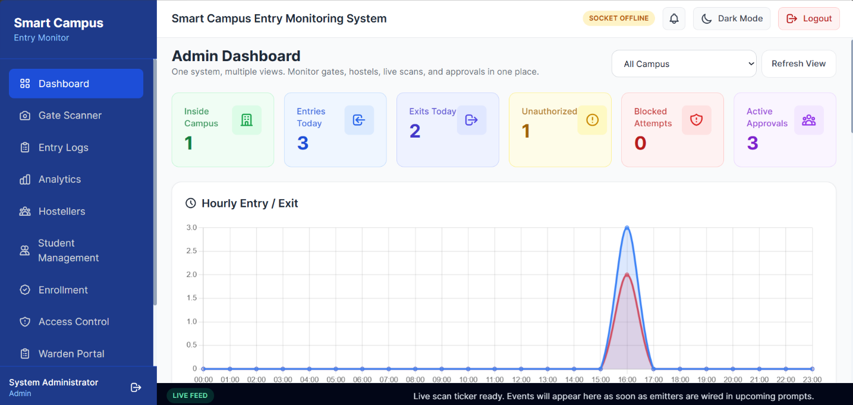
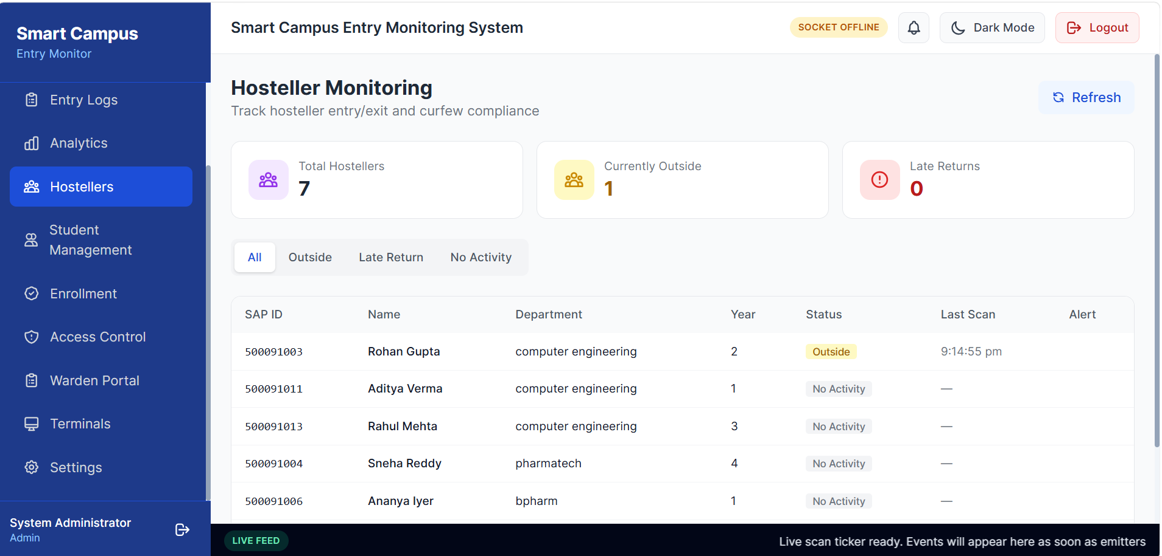
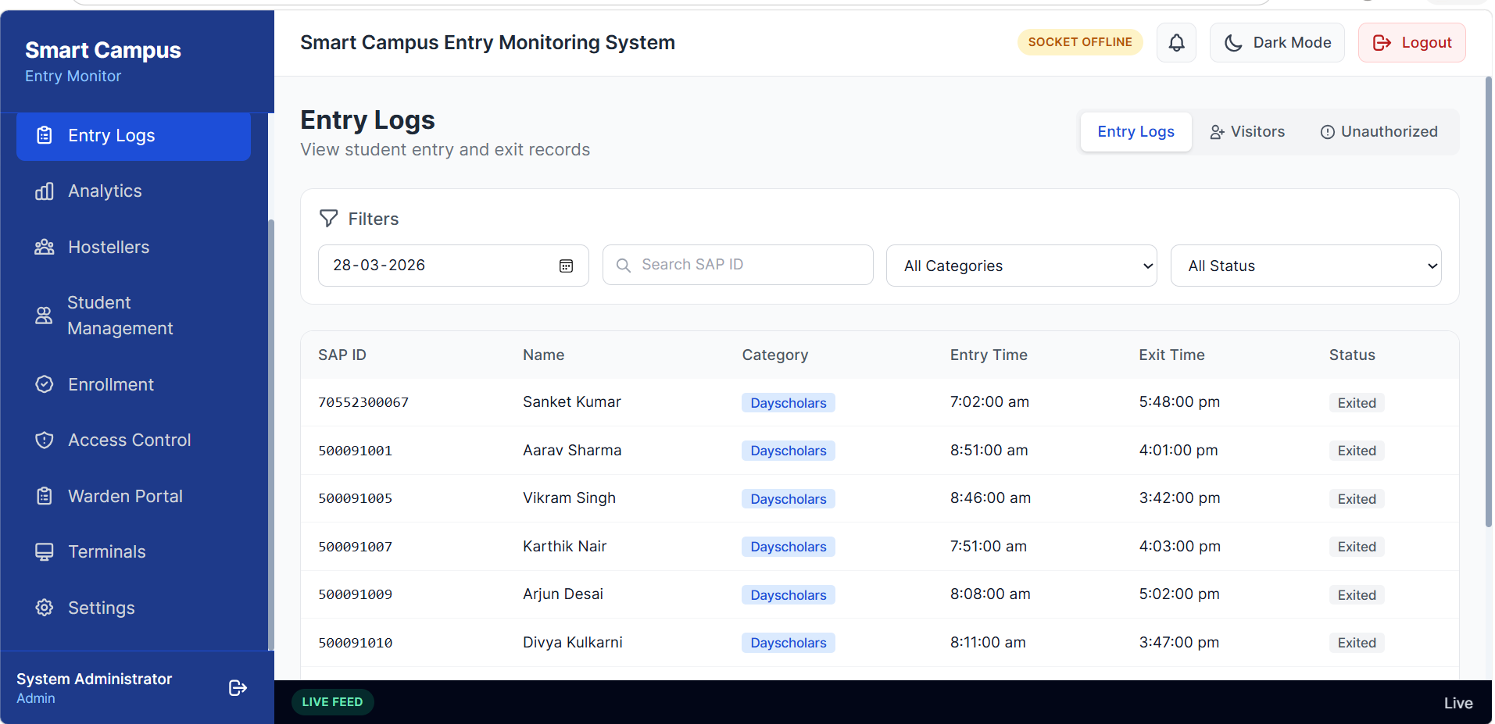

5. Why Industrial Biometric Terminal — Justification
This is the most critical design decision in the system. The eSSL X990 is selected over DIY alternatives such as ESP32 microcontrollers, Raspberry Pi setups, and industrial PC-based solutions. The justification is detailed below:

4.1 Reliability — Primary Justification
The eSSL X990 is an industrial-grade biometric terminal manufactured by eSSL Security — one of India's largest access control companies with over 1 million devices deployed across banks, corporate offices, schools, hospitals, and government institutions. The X990 is specifically designed for 24/7 continuous operation with a mean time between failure exceeding 10 years.

Factor | ESP32 Microcontroller | Raspberry Pi 4 | Industrial PC + Scanner | eSSL X990
Designed for 24/7 use | ❌ No | ⚠️ With cooling mods | ✅ Yes — if server-grade | ✅ Yes — industrial rated
Overheating | ❌ Throttles at 85°C | ⚠️ Needs heatsink case | ⚠️ Needs active cooling | ✅ Fanless, sealed enclosure
Crash / hang recovery | ❌ Manual watchdog code | ⚠️ Software watchdog | ⚠️ OS-level only | ✅ Hardware watchdog built-in
Expected lifespan | ❌ Under 6 months | ⚠️ 1 to 1.5 years | ⚠️ 3–5 years | ✅ 7–10 years
Appearance at gate | ⚠️ DIY, looks amateur | ⚠️ DIY, looks amateur | ❌ Bulky — not suitable for public gate | ✅ Professional, compact
Cost per terminal | ₹3,000–5,000 | ₹15,000–18,000 | ₹40,000–70,000+ | ₹11,500
Commercial warranty | ❌ None | ❌ None | ✅ PC vendor warranty | ✅ eSSL India support

4.2 Built-In Fingerprint Engine
The X990 handles the entire fingerprint pipeline internally — storage, matching algorithm, and verification — with results in under one second. This eliminates the need to build a matching system from scratch.

Capability | DIY (ESP32 + R503) | eSSL X990
Fingerprint storage | 200 templates max | 10,000 templates onboard
1:N matching (who is this?) | ❌ Must code manually — very hard | ✅ Built-in, under 0.5 seconds
Accuracy | Variable — depends on code quality | ✅ ISO-certified algorithm
Scale to 5,000 students | ❌ Impossible onboard | ✅ Yes — 10,000 capacity

4.3 Security and Data Privacy — Critical for College Approval
All fingerprint templates are stored encrypted inside the X990 terminal's internal flash memory. The backend server and database receive only a numeric user ID when a scan occurs — no biometric data ever leaves the terminal.

- Biometric data never stored in software database — compliant with IT Act 2000 Section 43A
- No risk of fingerprint data breach from the application layer
- If the server is compromised, no biometric information is exposed
- DIY systems must store templates in database — creating significant legal and privacy risk

This is the most important point for institutional approval — the college has zero liability for biometric data because it never enters the software system.

4.4 Plug-and-Play API Integration
The X990 has a built-in ePush protocol (ePush compatible) — it automatically sends every scan event to the configured backend URL over standard HTTP. No firmware development, no low-level hardware coding, no debugging embedded systems.

- Configure server URL once in device settings panel — device does the rest
- No hardware coding required — integration is pure Node.js backend development
- DIY alternatives require firmware development, UART communication coding, and ongoing hardware debugging

4.5 Performance at Scale
- Handles 10,000+ scans per day per terminal without any performance degradation
- Multiple terminals at multiple gates operate simultaneously on the same server
- 2,00,000 transaction log capacity — months of records stored on the device itself
- Offline standalone mode — if server goes down, terminal continues accepting scans locally and syncs when server returns
- ESP32 with 520KB RAM cannot handle 10,000 student templates or simultaneous multi-gate operation

4.6 Low Maintenance
- No OS to update, no software to patch, no cooling system to maintain
- eSSL India provides dealer network support across India — vendor is reachable
- Firmware updates via USB pendrive if ever needed — no technical expertise required
- DIY systems require developer intervention for every hardware issue — not sustainable

4.7 Cost vs Value
Solution | Hardware Cost | Reliability | Maintenance | Lifespan | Verdict
ESP32 + R503 + custom build | ₹3,000–5,000 | ❌ Unstable | ❌ High — developer needed | ❌ Under 6 months | ❌ Not suitable
Raspberry Pi 4 + Suprema | ₹15,000–18,000 | ⚠️ Good | ⚠️ Medium | ⚠️ 1 to 1.5 years | ❌ Not suitable
Industrial PC + Scanner | ₹40,000–70,000+ | ✅ Good | ⚠️ Medium — IT staff needed | ⚠️ 3–5 years | ❌ Too costly, looks bad at gate
eSSL X990 | ₹11,500 | ✅ Industrial | ✅ Near zero | ✅ 7–10 years | ✅ Recommended

Slightly higher cost than a DIY microcontroller setup ensures long-term reliability, eliminates maintenance overhead, and removes legal liability — making it the most cost-effective choice over the system's lifetime.

6. System Architecture
The architecture follows a three-tier model: hardware terminals at gates, a central backend on the college server, and a publicly accessible frontend dashboard.

6.1 Complete Data Flow
Step | What Happens | Who Does It
1 | Student places finger on X990 terminal | Student
2 | Terminal matches fingerprint against 10,000 onboard templates in <0.5 second | X990 hardware
3 | Terminal pushes scan event to backend: { userId, deviceSN, machineNumber, timestamp } | X990 → College LAN → Server
4 | Backend checks student's access status in MongoDB (allowed / blocked) | Node.js backend
5 | Backend runs entry/exit toggle logic and saves audit log | Node.js + MongoDB
6 | Backend sends parent email via Amazon SES | Amazon SES SMTP
7 | Backend broadcasts real-time event to all open dashboards via Socket.io | Socket.io
8 | Backend responds to terminal: { allow: true/false } | Node.js → eSSL X990
9 | Terminal shows green LED + beep (allow) or red LED + alarm (deny) | X990 hardware

Important: No fingerprint template is ever transmitted in any of these steps. Only a numeric user ID (e.g. 42) travels from the terminal to the backend. The backend maps this to a student SAP ID stored in MongoDB.

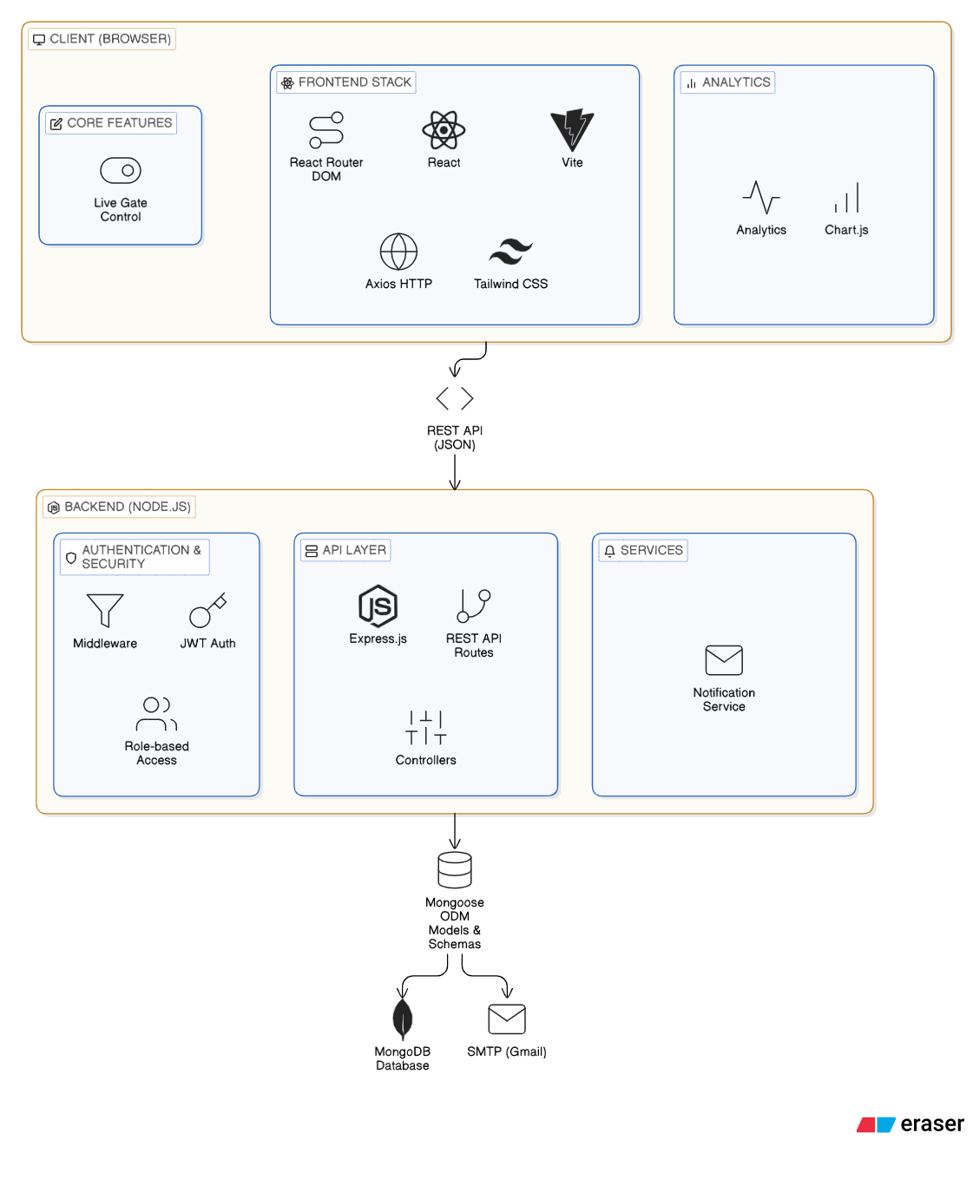

6.2 Gate and Terminal Numbering
Each terminal is configured with a unique machine number for full traceability on every log entry and dashboard alert:

Gate | Terminal 1 | Terminal 2 | Terminal 3
Main Gate | 101 | 102 | 103

Every log entry, dashboard alert, and parent notification includes the exact gate name and terminal number — e.g. 'Rahul Sharma — ENTRY — Main Gate Terminal 2 — 09:14:32'.

6.3 Network — Separate Power and LAN
Each X990 terminal uses independent power supply and a dedicated LAN cable — no Power over Ethernet (POE) switch is used. This approach is more flexible and allows terminal placement anywhere with a nearby power socket, without dependency on POE-compatible networking equipment.

- Each terminal plugged into standard 12V power adapter at the wall — independent of network equipment
- Each terminal connected via its own Cat6 Ethernet cable to the gate switch
- Gate switch connected to main college LAN which reaches the server PC
- If one terminal's power or cable fails, all other terminals continue operating — no single point of failure
- Standard 8-port unmanaged switch (non-POE) used at gate — cheaper and simpler than POE switch

7. Key Features

7.1 Security — Fingerprint Authentication & Access Control
- Fingerprint-based authentication — no ID cards, no PINs, no manual verification
- 10,000 fingerprint template capacity — sufficient for entire student body
- Unauthorized access detection — unknown fingerprint triggers instant alarm and dashboard alert
- Admin block/unblock — any student can be denied access instantly from dashboard with reason logging
- Blocked student attempts logged separately from unknown fingerprint attempts — full traceability
- Anti-passback — terminal prevents two entries without an exit in between
- Unknown terminal rejection — scan from unregistered device is rejected and admin alerted
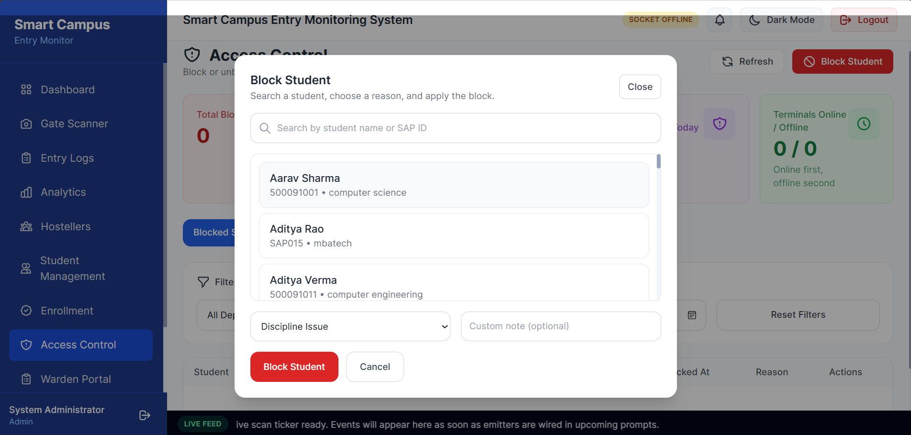
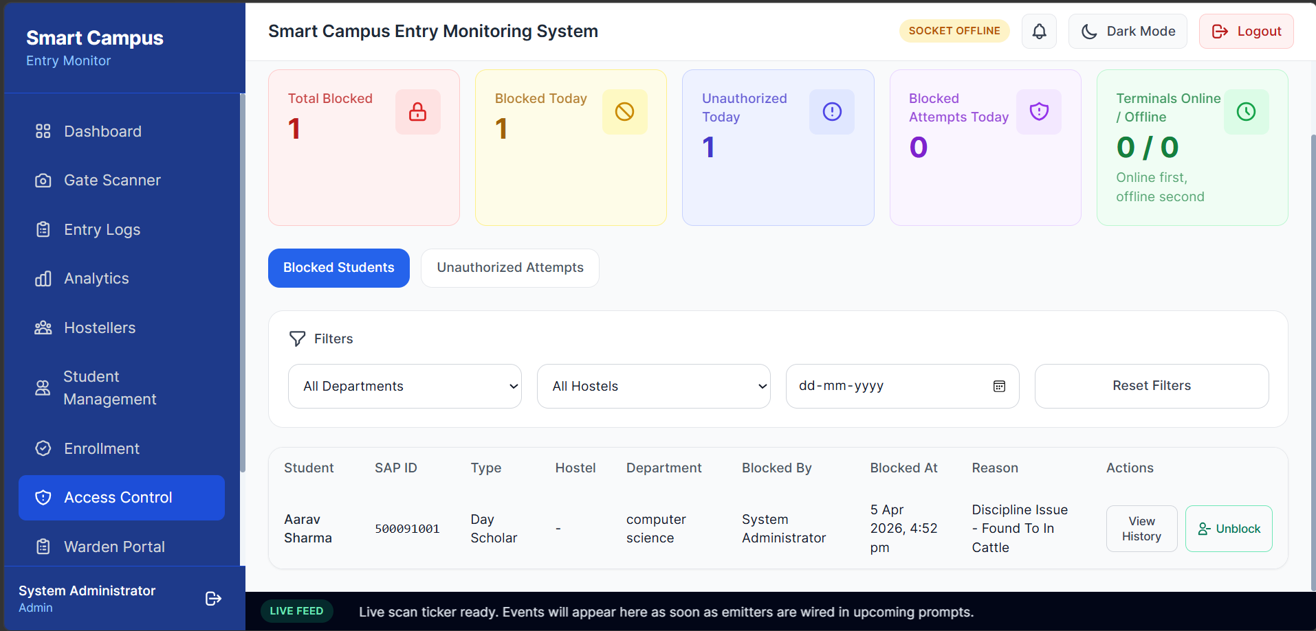

7.3 Real-Time Monitoring Dashboard
- Live scan feed — every entry and exit appears on all open dashboards instantly via Socket.io
- Gate-wise terminal status — online/offline indicators with last seen time and scans today count
- Hourly entry/exit chart, peak hours analysis, and department-wise breakdown
- Public /live page — no login required, accessible by parents, staff, and management from anywhere
- Cloudflare Tunnel — free permanent HTTPS URL, no IT department involvement, no port forwarding
- News ticker at bottom of all dashboard pages showing last 5 scan events in real time

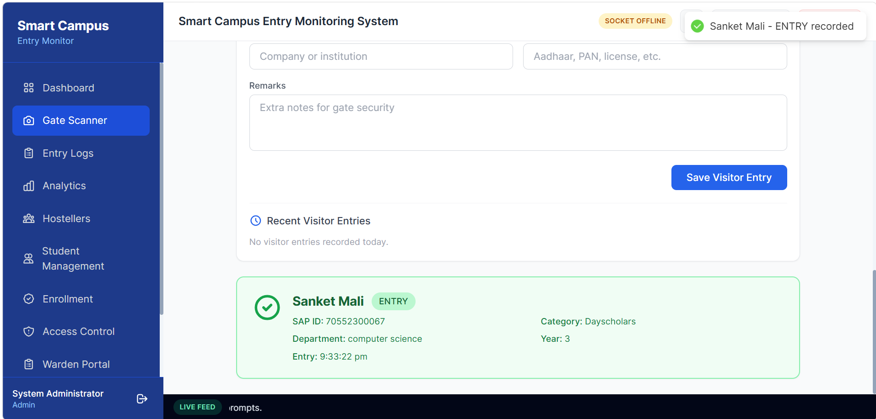

7.4 Parent Communication — Email via Amazon SES
- Automated email to parent on every student entry and exit
- Email includes: student name, SAP ID, entry/exit type, gate name, terminal number, and exact timestamp
- Amazon SES used for delivery — $1 per 10,000 emails, approximately ₹1,150/month for 4,000 emails/day
- Gmail or free SMTP not used — unreliable at scale, 500/day limit, spam risk
- Amazon SES delivers to inbox reliably — 99.9% deliverability rate
- Additional email alerts for: blocked student attempt, unauthorized access
- Manual resend option — admin can resend any notification from the dashboard

7.5 Analytics and Reporting
- Real-time campus population count — number of students currently inside campus
- Today's total entries, exits, unauthorized attempts, and blocked attempts
- Hourly traffic chart — identify peak entry and exit times
- Weekly and monthly trends — data-driven security decisions for administration
- Per-gate and per-terminal breakdown — identify high-traffic or problematic entry points
- CSV export of all logs — importable into Excel for offline analysis
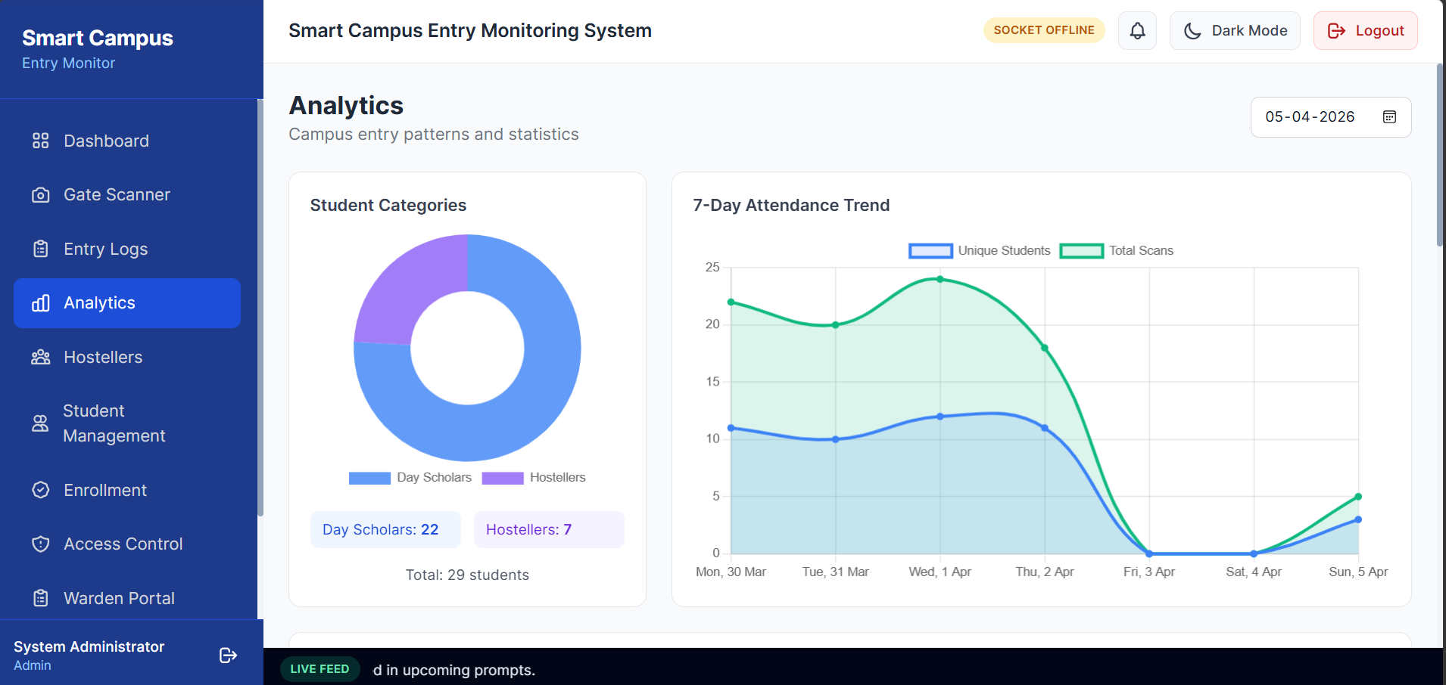
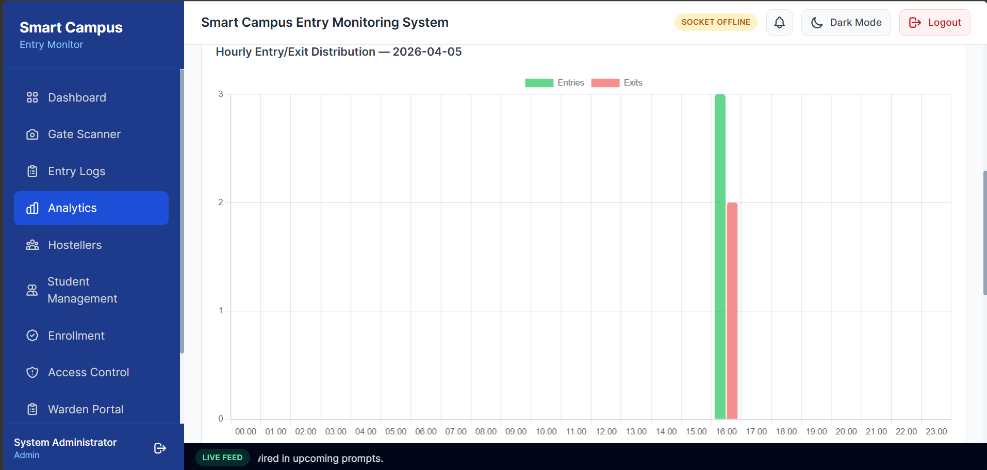
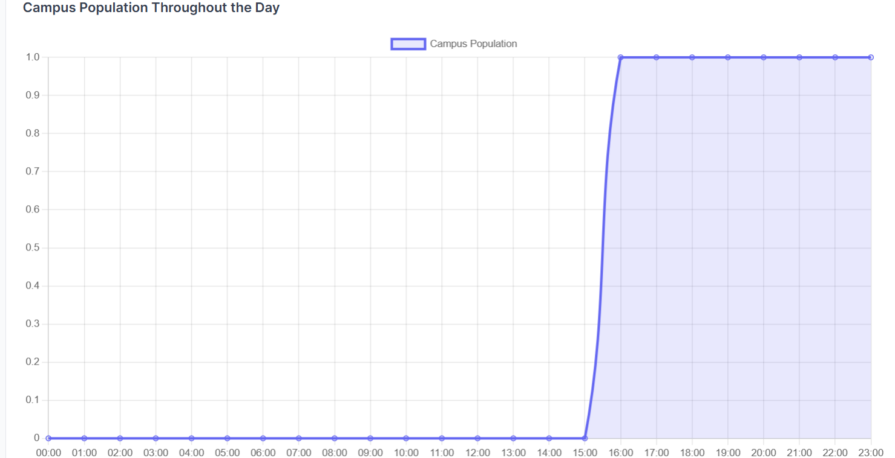

8. Notification and Communication System

8.1 Email — Amazon Simple Email Service (SES)
Amazon SES is selected as the email delivery provider for the following reasons:

- Gmail SMTP — limited to 500 emails per day, unreliable for automated sending, risk of account suspension at scale
- Amazon SES — purpose-built transactional email service, 99.9% deliverability, used by Amazon itself for all order notifications
- Pricing: $1 per 10,000 emails — at 4,000 emails per day (1,20,000/month) total cost is approximately $12/month (₹1,000/month)
- Integration: works directly with existing Nodemailer in the project — only 4 environment variables change, zero code changes
- Sandbox to production: AWS approves production access within 24 hours upon request

Service | Daily Limit | Monthly Cost at 4,000/day | Deliverability | Verdict
Gmail SMTP | 500 emails | ❌ Cannot do it | Poor for bulk | ❌ Not suitable
Brevo Free | 300 emails | ❌ Cannot do it | Good | ❌ Not suitable
Brevo Paid | Unlimited | ₹6,500/month | Good | ⚠️ Expensive
SendGrid | Unlimited | ₹7,000/month | Excellent | ⚠️ Expensive
Amazon SES | Unlimited | ₹1,000/month | Excellent | ✅ Recommended

8.2 What Each Email Contains
Event | Recipients | Email Content
Student Entry | Parent | Student name, SAP ID, ENTRY, gate name, terminal, exact time
Student Exit | Parent | Student name, SAP ID, EXIT, gate name, terminal, exact time
Blocked student attempt | Security + Admin | Student name, block reason, gate, terminal, time
Unauthorized access | Security + Admin | Gate name, terminal, time, attempt count today
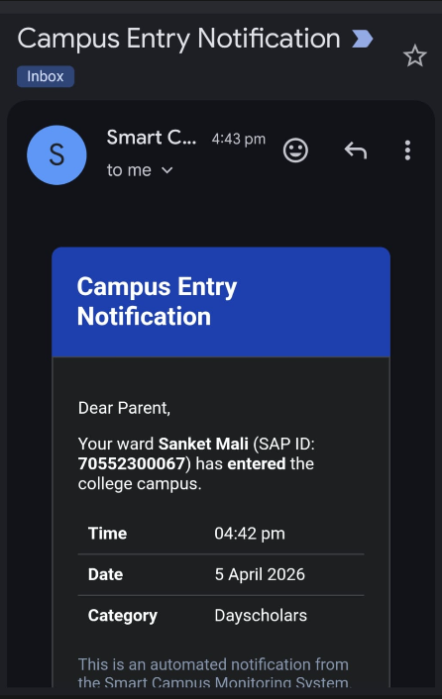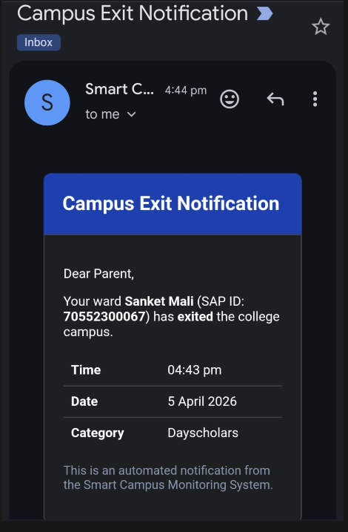

9. Risk Handling and Contingency Planning
A production campus security system must handle failure scenarios gracefully. The following risks are identified and mitigated:

Risk | Probability | Mitigation
Server PC goes offline | Low | X990 continues operating in standalone mode — stores up to 1,00,000 scans locally, syncs automatically when server returns
Terminal LAN cable disconnects | Low | Only that specific terminal goes offline — all other terminals continue normally. Dashboard shows offline alert immediately via Socket.io
Terminal power cut | Low | Only that terminal affected — others continue. Gate UPS provides 30–45 minutes backup. Security notified via dashboard alert
Internet outage at college | Medium | Terminals connect to server via LAN — internet not required for gate operation. Only parent email delivery pauses until internet restores
Wrong person fingerprint match (false accept) | Very Low | FAR of ISO-certified algorithm is 0.001% — statistically negligible. Anti-passback adds additional layer
Student fingerprint not recognised (false reject) | Low | FRR is 0.1% — student retries. Security guard can manually log entry as override. Fingerprint re-enrollment resolves persistent cases
Amazon SES email delivery failure | Very Low | SES has 99.9% SLA. Failed emails retried automatically. Dashboard logs all notification attempts with status
Unauthorised terminal connects to system | Prevented | Backend validates device serial number on every scan — unregistered device rejected and admin alerted immediately
Student biometric data breach | Not applicable | Fingerprint templates stored only inside X990 hardware — never in the application database

10. Scalability
The system is architected to scale from a single gate demo to full campus deployment with no architectural changes:

- Additional gates: Mount more X990 terminals, assign machine numbers, plug into LAN — operational in minutes
- Student capacity: eSSL X990 supports 10,000 fingerprints — current college enrollment of ~5,000 is well within limit
- Multiple gates simultaneously: All terminals push to the same server — backend handles concurrent events from all gates
- Future face recognition: eSSL face recognition series supports face + fingerprint — same ePush Push protocol, same backend integration
- Staff attendance: Same terminals can handle staff with separate access profiles — no additional hardware
- RFID card backup: eSSL X990 optionally supports IC/ID card scanning — students without fingerprint enrollment can use card
11. Hardware Components — Selection and Justification

11.1 eSSL X990 — Gate Fingerprint Terminal
Quantity (Demo Pilot): 2 units

Specification | Value
Fingerprint Capacity | 10,000 templates onboard
Card Capacity | 10,000 (inbuilt proximity card reader — Mifare/HID optional)
Transaction Log Capacity | 200,000 records
Display | 3.5 inch colour TFT
Fingerprint Verification Speed | Under 0.5 seconds
Communication | TCP/IP Ethernet, RS232/485, USB Host/Client
Push Protocol | ePush Protocol (ePush compatible) — automatic HTTP POST to backend
Access Control Interfaces | Electric lock relay, door sensor, exit button, alarm, Wiegand I/O
Optional Modules | IC card, WiFi, 4G SIM, Webserver
Standalone Offline Mode | Yes — continues locally, syncs on reconnect
Anti-Passback | Yes
Built-in Alarm Relay | Yes — for external buzzer or door lock
Battery Backup | Yes — built-in, continues during power cut
Door Bell | Yes
Door Sensor | Yes
Exit Reader Support | Yes — KR500, KR503, Push Button
Operating Temperature | 0°C to 45°C
Power Supply | 12V DC via standard adapter
Data Backup | USB pendrive export
Certifications | ISO 19794-2, CE

11.2 Dedicated eSSL X990 — Admin Enrollment Station
Quantity (Demo Pilot): 1 unit (one of the 2 purchased X990 terminals is used temporarily as enrollment station before gate installation)
The enrollment station is the same eSSL X990 model as the gate terminals — placed on a desk in the admin office during the enrollment drive. Students visit in department-wise batches, place their finger directly on the device, and are enrolled. After the enrollment drive is complete, this terminal is mounted at the gate permanently.

Using a dedicated biometric device for enrollment ensures reliability, eliminates compatibility issues, and aligns with industry-standard practices. Since the enrollment terminal is identical to the gate terminals, fingerprint templates are guaranteed to be fully compatible — no conversion, no SDK, no risk.

Why This Approach — Key Justifications
- Same device family — enrollment X990 and gate X990 use identical fingerprint sensors and template formats. No conversion or compatibility issues.
- No biometric data stored on server during enrollment — student places finger directly on X990, template stored internally on device. Backend only pulls template after enrollment for sync purposes.
- No expensive USB scanner needed — Suprema BioMini Plus 2 (₹9,000) is completely eliminated. The second X990 serves as enrollment station at zero extra cost.
- Industry-standard practice — enterprises and institutions worldwide use one terminal as enrollment station and sync to all other terminals via SDK.
- Comfortable indoor experience — admin office desk, not outdoor gate terminal. Students sit down, admin guides them, quality is verified before confirmation.

Enrollment Workflow — Step by Step
Step | Who Does It | What Happens
1 | Admin | Opens enrollment page on admin PC — searches student by name or SAP ID
2 | Admin | Assigns a unique User ID (e.g. 42) to the student in the system
3 | Admin | Selects student type: Day Scholar or Hosteller (Hosteller management and hostel room assignment is planned for a future phase)
4 | Admin | Clicks Start Enrollment — system creates user slot on enrollment X990 via ZK protocol
5 | Student | Places finger on enrollment X990 device screen — X990 captures and stores template internally
6 | Student | Places finger again for confirmation — X990 verifies quality match
7 | Admin | Clicks Confirm — backend pulls template from enrollment X990 via ZK protocol (port 4370)
8 | Backend | Encrypts template with AES-256 and stores in MongoDB against student record
9 | Backend | Automatically pushes template to all registered gate X990 terminals via ZK protocol
10 | Dashboard | Shows enrolled status — student is now active on all gate terminals

Data Privacy — What Is and Is Not Stored
Data | Stored Where | Accessible To
Fingerprint template (raw biometric) | Enrollment X990 (during drive) + Gate X990 terminals | Hardware only — never readable from software
Fingerprint template (encrypted copy) | MongoDB — AES-256 encrypted | Backend only — used for syncing new terminals. Can be deleted after full deployment.
User ID (e.g. 42) | MongoDB + X990 terminals | Backend and admin dashboard
Student profile (name, SAP ID, hostel) | MongoDB only | Admin dashboard — no biometric link

Note: The encrypted template in MongoDB is stored solely to enable syncing new gate terminals in future without re-enrolling students. If the college prefers maximum privacy, templates can be deleted from MongoDB after all terminals are synced — new terminals would then require a fresh enrollment drive.

11.3 College Server PC
Quantity: 1 (existing college PC can be used if available)
Specification | Minimum | Recommended
Processor | Intel Core i3 (10th Gen) | Intel Core i5 (12th Gen)
RAM | 8 GB DDR4 | 16 GB DDR4
Storage | 256 GB SSD | 512 GB SSD
OS | Ubuntu Server 22.04 LTS | Ubuntu Server 22.04 LTS
Network | Gigabit Ethernet (mandatory) | Gigabit Ethernet
UPS | 1 KVA (mandatory) | 2 KVA

11.4 Network Switch — Standard (Non-POE)
Quantity: 1 unit at gate
A standard 8-port Gigabit unmanaged switch (e.g. TP-Link TL-SG108) is used at the gate. Each terminal uses its own separate 12V power adapter and its own Cat6 cable to the switch. No POE required.

- Standard unmanaged switch — plug-and-play, no configuration, fanless
- Cheaper than POE switch — approximately ₹800–1,200 vs ₹2,500–3,000 for POE
- Terminals powered independently via 12V adapter at wall socket — more flexible placement
- Gigabit speed ensures scan events reach server in under 50ms

11.5 Cables and Power
Item | Purpose | Qty
Cat6 Ethernet Cable 10m | Each terminal to gate switch | 2
Cat6 Ethernet Cable 20m | Gate switch to server PC (via college LAN) | 1
12V 2A DC Power Adapter | Independent power for each X990 terminal | 2
UPS 600VA (APC BX600C-IN) | Backup for gate switch and connectivity equipment | 1
UPS 1–2KVA | Server PC power backup | 1

12. Implementation Plan
Phase | Activities | Duration | Deliverable
Phase 1 — Software Deployment | Set up server PC with Ubuntu, Docker, and docker-compose. Deploy Node.js backend, MongoDB, and React frontend. Configure Cloudflare Tunnel for public dashboard access. | Week 1 | System accessible on LAN and via public URL
Phase 2 — Hardware Installation | Mount X990 terminals at gate. Connect each terminal to its 12V power adapter and Cat6 cable to switch. Configure ePush push URL on each terminal. Assign machine numbers. | Week 1–2 | Terminals pushing scan events to backend
Phase 3 — Feature Development | Implement fingerprint integration, access control, Socket.io real-time, Amazon SES email, public dashboard, and terminal management. | Week 2–4 | All features operational
Phase 4 — Student Enrollment | Place one X990 terminal on admin office desk. Enroll students batch by batch, department by department. Backend automatically pulls templates and pushes to gate terminal. After drive, enrollment X990 is mounted at gate. | Week 5 | All enrolled students active on all terminals
Phase 5 — Testing and Go-Live | Load testing with real students. Test offline scenarios, late return alerts, blocked access, and parent email delivery. Security guard training. | Week 6 | Pilot gate live and monitored

13. What the College Needs to Provide
Requirement | Details | Complexity
Power socket at gate | Standard 230V socket near each terminal mounting location for 12V adapter | Electrician — 1 hour
Wall mounting permission | Permission to drill and mount 2 terminal brackets at pilot gate | Admin approval only
LAN cable run | Single Cat6 cable from server room to gate switch location | IT / electrician — half day
Server PC | Existing college PC (i3/i5, 8GB+ RAM, SSD) — or approval to procure | Nil if existing PC available
Server room space | Secure indoor room for the server PC | Nil — any existing room
Enrollment drive window | 2 weeks for students to visit admin desk in department-wise batches | Administrative scheduling
AWS account for SES | Free AWS account — developer configures everything | Nil — developer handles

The college does NOT need to involve IT department beyond one LAN cable run, purchase cloud subscriptions, configure network settings, or maintain any software. All remote management is handled by the developer via SSH.

14. Anticipated Questions and Answers
The following questions are likely to arise during review and are addressed proactively:

Q1 — Why not use RFID cards instead of fingerprint?
RFID cards can be shared, lost, forgotten, or cloned. A student can hand their card to a friend to mark attendance on their behalf — defeating the purpose of the system. Fingerprint is non-transferable — only the actual student can authenticate. eSSL X990 also supports optional RFID as a fallback for students whose fingerprint cannot be enrolled due to skin conditions.

Q2 — What if the terminal fails?
The X990 has a hardware watchdog — it self-restarts if it hangs, unlike microcontrollers that need manual power cycling. If a terminal goes permanently offline, the dashboard alerts admin and security immediately via Socket.io. The security guard falls back to manual logging — the same process used today — while the terminal is replaced. eSSL India provides replacement units through their nationwide distributor network.

Q3 — Is student fingerprint data safe and legally compliant?
Yes. Fingerprint templates are stored only inside the X990 terminal's internal flash memory — encrypted and inaccessible from outside. The application server and database never receive, store, or process any biometric data. Only a numeric user ID is transmitted when a student scans. This architecture ensures full compliance with IT Act 2000 Section 43A and makes the college legally clear of any biometric data liability.

Q4 — What is the ongoing cost after hardware purchase?
The only recurring cost is Amazon SES email delivery — approximately ₹1,000 per month for 4,000 emails per day (entry + exit notifications to parents). There are no cloud server costs since the college server PC hosts all software. There are no software licensing fees — the entire stack is open source.

Q5 — Who maintains the system after implementation?
The system runs in Docker containers on the college server PC. The backend, database, and frontend restart automatically if they crash — no manual intervention needed for normal operation. Software updates are deployed remotely via SSH by the developer. Hardware terminals are maintained by ZKTeco's India support team.

15. Benefits to College
Stakeholder | Benefits
Administration | Automated student tracking, digital audit trail, data-driven decision making, zero manual register maintenance
Security Guards | No manual ID verification, instant alert on unauthorized or blocked students, clear gate and terminal identification on every event
Parents | Instant email notification every time their child enters or exits campus — complete peace of mind
IT / Management | Live public dashboard accessible anywhere, historical analytics, fully digital and searchable records for incident investigation

16. Final Component List — Demo Pilot (2 Terminals, 1 Gate)
Every item required for the complete demo pilot. Nothing additional is needed beyond this list. Existing college PC eliminates the server hardware cost.

# | Component Full Name | Purpose | Qty | Unit Cost | Total |  | Buy From
1 | eSSL X990 Biometric Fingerprint Terminal | Gate scanner — 10,000 FP capacity, ePush push, built-in alarm relay, offline mode, TCP/IP Ethernet | 2 | ₹11,500 | ₹23,000 |  | eSSL dealer / IndiaMART
2 | eSSL X990 — Enrollment Station (one of the 2 purchased units) | Temporarily placed at admin desk for student enrollment drive. Relocated to gate after drive completes. No extra purchase needed. | — | Included in item 1 | ₹0 extra |  | Same as item 1
4 | TP-Link TL-SG108 8-Port Gigabit Switch (Standard, Non-POE) | Connects both terminals and server PC via LAN at gate | 1 | ₹1,000 | ₹1,000 |  | Amazon India
5 | Cat6 Ethernet Cable — 10 Metre | Terminal to gate switch — one per terminal | 2 | ₹350 | ₹700 |  | Amazon India
6 | Cat6 Ethernet Cable — 20 Metre | Gate switch to server PC via college LAN | 1 | ₹600 | ₹600 |  | Amazon India
7 | Desktop PC — Intel i5, 16GB RAM, 512GB SSD | College server running Node.js + MongoDB + Docker | 1 | Existing | — |  | College asset
8 | APC UPS 1KVA — Server | Power backup for college server PC | 1 | Existing | — |  | College asset
9 | APC Back-UPS BX600C-IN 600VA UPS | Power backup for gate switch during power cuts | 1 | Existing | — |  | College asset
10 | Desktop PC — Any Specs | Gate monitoring, live entry/exit logs, biometric sync, SAP entry | 1 | Existing | — |  | College asset
11 | Desktop PC — Any Specs | Admin dashboard, analytics, student management, system control | 1 | Existing | — |  | College asset
12 | Mini 12V Wired Sound Alarm Strobe Flashing Light Siren Security System 110dB | Audible alert for unauthorized access and security events via biometric system | 2 | ₹750 | ₹1500 |  | Amazon India
TOTAL (excluding server PC if existing college PC used) |  |  |  |  |  | ₹26,800

Note: eSSL X990 unit price is ₹11,500 inclusive of GST as quoted by eSSL India. Confirm with vendor before finalising budget.

Recurring Operational Costs (Monthly)
Service | Purpose | Monthly Cost
Amazon SES | Email delivery — 4,000 emails/day (1,20,000/month) to parents | ~₹1,000/month (~$12)
Cloudflare Tunnel | Public HTTPS URL for dashboard | Free
Total Recurring |  | ~₹1,000/month

17. Development Cost and Value Justification
The Smart Campus Entry Monitoring System is a comprehensive, production-grade solution encompassing real-time monitoring, biometric hardware integration, access control, automated approval workflows, and a publicly accessible live dashboard. The development cost reflects not merely software creation, but the complete system design, scalability architecture, security implementation, and long-term institutional usability.

Unlike off-the-shelf attendance software, this system is custom-built for SVKM NMIMS MPSTME, Shirpur — integrating directly with biometric hardware, college-specific workflows, and the exact operational needs of security and administration staff.

17.1 Key Factors Contributing to Development Effort
1. Full-Stack System Development
- Backend API development — Node.js and Express.js with 40+ REST API routes
- Database design and optimisation — MongoDB with 12+ collections, proper indexing for performance at scale
- Frontend dashboards — React.js with real-time Socket.io updates across 8 dashboard pages
- Role-based authentication and authorisation — admin, security, and public roles with route-level enforcement

2. Advanced Feature Integration
- Biometric device integration via ePush protocol — eSSL X990 terminal push event handling, device authentication, sync commands
- Real-time communication using Socket.io — live updates to all connected browsers without page refresh
- Automated parent notification system via Amazon SES — 4,000+ emails per day at institutional scale
- Access control system — block/unblock with audit trail, separate logging for blocked vs unauthorized attempts

3. System Architecture and Scalability
- Multi-gate and multi-terminal support — unlimited gates via machine number convention, all managed from dashboard
- Real-time data synchronisation across all dashboards simultaneously via Socket.io rooms
- Modular and scalable design — adding a new gate requires zero code change, only terminal registration in dashboard
- Docker-based containerisation — backend, frontend, and database all containerised for consistent deployment

4. Testing and Simulation Capability
- System can be fully tested without physical hardware using simulation mode — mock scan events via API
- Reduces initial deployment risk — all workflows verified in software before hardware arrives
- Ensures stability before live implementation with real students

5. Deployment and Long-Term Maintainability
- Docker-based deployment — entire system up in one command: docker-compose up
- Remote management via SSH — developer can deploy updates, fix issues, and monitor logs without visiting college
- Cloudflare Tunnel — public dashboard access configured once, works permanently with no IT department involvement
- Immutable audit log — every admin action logged with before/after values, searchable and exportable
- SystemConfig collection — all operational settings managed from UI, no code or server restart needed

17.2 Value to the Institution
Value Area | Description | Tangible Benefit
Administrative Efficiency | Replaces manual gate registers entirely | Security guard time saved — approx. 2–3 hours per day per gate
Campus Security | Instant alert on unauthorized or blocked student scan | Zero blind spots — every entry and exit is recorded and alerted
Parental Transparency | Instant email to parent on every entry/exit | Reduces parent phone calls to admin asking about child's whereabouts
Data-Driven Decisions | Peak hour analytics, gate traffic breakdown | Administration can optimise guard deployment and gate scheduling
Legal Protection | Biometric data never stored in software | College has zero liability under IT Act 2000 Section 43A
Long-Term Cost Saving | Automated system replaces manual processes | ROI achieved within first academic year through labour and error reduction

17.3 Why This Investment Makes Sense
Comparison Point | Manual System (Current) | This System
Entry recording time | 5–10 seconds per student (manual writing) | Under 1 second (fingerprint scan)
Data accuracy | Prone to errors, omissions, and falsification | 100% digital, tamper-proof, timestamped
Real-time visibility | Zero — admin has no live data | Live dashboard — anyone with link can view
Parent notification | None | Instant email on every entry/exit
Unauthorized entry detection | Depends on guard vigilance | Automatic alarm + dashboard alert
Incident investigation | Paper records — incomplete | Searchable digital logs — exact timestamps
Scalability | Requires more guards per gate | Add terminal → plug in → works immediately

18. Justification for Using Industrial Biometric Device
The system uses the eSSL X990 industrial biometric terminal — a purpose-built, commercially certified fingerprint access control device — instead of microcontroller-based solutions such as ESP32 or Raspberry Pi. This is not merely a cost decision but a fundamental requirement for institutional-grade reliability, security, and legal compliance.

"The system uses industry-grade biometric terminals instead of microcontroller-based solutions to ensure reliability, security, scalability, and compliance with data privacy standards."

18.1 Reliability and 24/7 Operation
Industrial biometric devices are engineered and certified for continuous, uninterrupted operation in real-world environments — harsh temperatures, dust, humidity, and constant physical contact from thousands of users per day.

- eSSL X990 is deployed in banks, hospitals, government institutions, factories, and educational campuses across India — proven in environments far more demanding than a college gate
- Designed for 24/7 operation with a mean time between failure exceeding 10 years
- Hardware watchdog built-in — device self-restarts automatically if it ever hangs, without any human intervention
- Built-in battery backup — terminal continues operating even during a power cut
- ESP32 microcontrollers are consumer-grade hobbyist components — not rated for continuous outdoor operation, expected lifespan under 6 months in gate environments
- Raspberry Pi 4 has no hardware watchdog, overheats without active cooling, and has an expected lifespan of 1 to 1.5 years in always-on deployment

18.2 Built-In Biometric Processing Engine
The eSSL X990 contains a dedicated fingerprint processing chip with ISO-certified matching algorithm — entirely separate from the device's main processor. This is not software running on a general-purpose CPU.

- Onboard 1:N matching — device matches a live fingerprint against all 10,000 stored templates in under 0.5 seconds
- FAR (False Acceptance Rate) of 0.0001% — one wrong person accepted per one million attempts
- FRR (False Rejection Rate) of 1% — simple retry resolves this in practice
- Building an equivalent matching system on ESP32 or Raspberry Pi would require months of development, still achieve lower accuracy, and remain impractical at 5,000 student scale

18.3 Data Security and Privacy Compliance
This is the most important point for institutional approval. The eSSL X990 stores all fingerprint templates in its own internal encrypted flash memory. The backend application and MongoDB database never receive, handle, or store any biometric data whatsoever.

- Only a numeric user ID (e.g. 42) is transmitted from terminal to backend when a student scans — no fingerprint data travels over the network
- If the server is hacked, breached, or physically stolen — no biometric data is exposed
- Fully compliant with IT Act 2000 Section 43A — college bears zero liability for biometric data
- DIY systems using ESP32 or Raspberry Pi must transmit fingerprint templates over the network and store them in the database — creating serious legal and privacy risk that no educational institution should accept

The eSSL X990 architecture makes it legally impossible for the college to suffer a biometric data breach at the application level — because the application never sees the biometric data.

18.4 Seamless API Integration
- eSSL X990 has built-in ePush protocol (ADMS compatible) — automatically sends every scan event to the configured backend URL via standard HTTP POST
- Integration requires zero hardware programming — only backend Node.js development
- Device serial number authentication ensures only registered terminals can push data to the backend
- Commands can be sent back to the terminal (add user, delete user) via the terminal's built-in HTTP server
- DIY alternatives require custom firmware development, UART serial communication coding, hardware debugging, and ongoing maintenance — adding months of development time and significant technical risk

18.5 Scalability and Multi-Device Support
- Adding a new terminal: register machine number in dashboard, configure server URL on device — operational in under 10 minutes
- All terminals at all gates push to the same backend simultaneously — no architectural change required
- Supports future face recognition upgrade: eSSL face recognition series uses identical ePush protocol — backend integration is the same
- ESP32 systems cannot scale — each additional terminal requires separate firmware, wiring, and debugging

18.6 Vendor Support and Maintenance
- eSSL Security is one of India's largest access control manufacturers — 1 million+ devices deployed nationwide
- Dealer network across India — replacement units available quickly if needed
- Firmware updates via USB pendrive — no technical expertise required at the installation site
- DIY systems have zero vendor support — every hardware failure requires the original developer to diagnose and repair

18.7 Cost vs Long-Term Value
Factor | ESP32 + Custom Build | Raspberry Pi 4 Setup | Industrial PC + Scanner | eSSL X990
Hardware cost per terminal | ₹3,000–5,000 | ₹15,000–18,000 | ₹40,000–70,000+ | ₹18,625 incl. GST
Expected lifespan | Under 6 months | 1 to 1.5 years | 3–5 years | 7–10 years
Replacement frequency | Every 6 months | Every 1–2 years | Every 3–5 years | Once in 10 years
10-year total cost (1 terminal) | ₹60,000–1,00,000 | ₹90,000–1,80,000 | ₹1,40,000–2,80,000 | ₹18,625 — one time
Maintenance effort | High — developer every failure | Medium — IT staff | Medium — IT staff | Near zero
Appearance at gate | Amateur — circuit boards | Amateur — SBC board | ❌ Bulky PC enclosure | ✅ Professional device

Although the eSSL X990 costs more upfront than an ESP32-based solution, the 10-year total cost of ownership is dramatically lower — and the reliability, legal compliance, and professional appearance are incomparably superior. This is the only choice that makes sense for a permanent institutional deployment.

18.8 Conclusion on Device Selection
Industrial biometric terminals are selected to ensure a robust, secure, and scalable system. This approach aligns with real-world deployment standards used by banks, government institutions, and enterprises across India. The eSSL X990 guarantees reliable performance, privacy compliance, and minimal maintenance — making it the only suitable choice for an institutional gate monitoring deployment that is expected to operate continuously for 7–10 years.

19. Future Work
The current proposal focuses exclusively on the Main Gate biometric monitoring system. The following features and expansions are planned for subsequent phases of deployment once the Main Gate pilot is successfully operational and approved by administration.

19.1 Hostel Gate Integration
Following successful Main Gate deployment, the system will be extended to all hostel gates. Hostel gates serve a smaller population (typically 500–1,000 hostellers) and can use lower-capacity terminals at reduced per-unit cost, making full campus rollout considerably more affordable. Each hostel gate terminal will be assigned a dedicated machine number range (e.g. 301–304) for full traceability in logs and dashboard alerts.

19.2 Warden Approval Workflow
Once hostel gates are active, a full warden approval workflow will be introduced. This includes: hostellers flagged in the system who cannot exit campus without active warden approval; a self-service web page for students to submit exit requests with reason and expected return time; a dedicated warden portal for real-time approval or rejection from any device; automatic expiry of approved exit windows; automated cron-based late return detection with instant alerts to both warden and parent; and a complete per-student exit history accessible by admin. Role-based access for wardens will be added alongside the existing admin, security, and public roles.

19.3 Extended Notification Coverage
With warden and hostel gate integration, the email notification system via Amazon SES will be extended to cover additional event types: hosteller late return alerts to parent and warden; warden approval granted notifications to student and parent including exit window and return deadline; warden rejection notifications to student with reason; and per-hostel configurable alert thresholds. All additional notifications will reuse the existing SES integration with no additional cost beyond current usage.

19.4 Additional Campus Gates
The system architecture supports unlimited gate expansion with zero code changes. After the Main Gate pilot, additional gates including the Back Gate and Library Gate can be brought online by simply adding terminals, assigning machine numbers (Back Gate: 201–204, Library Gate: 401–404), and connecting to the campus LAN. Each new terminal is operational within minutes of physical installation.
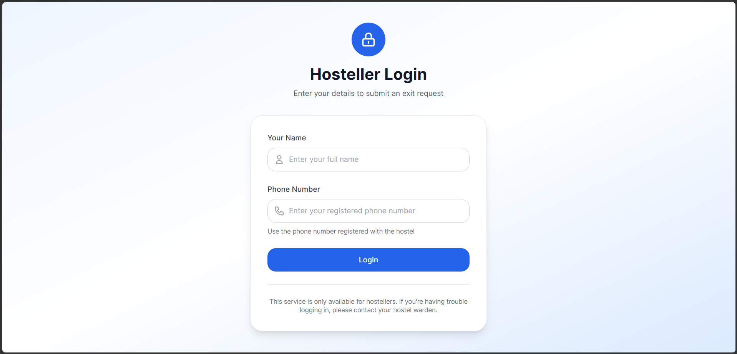
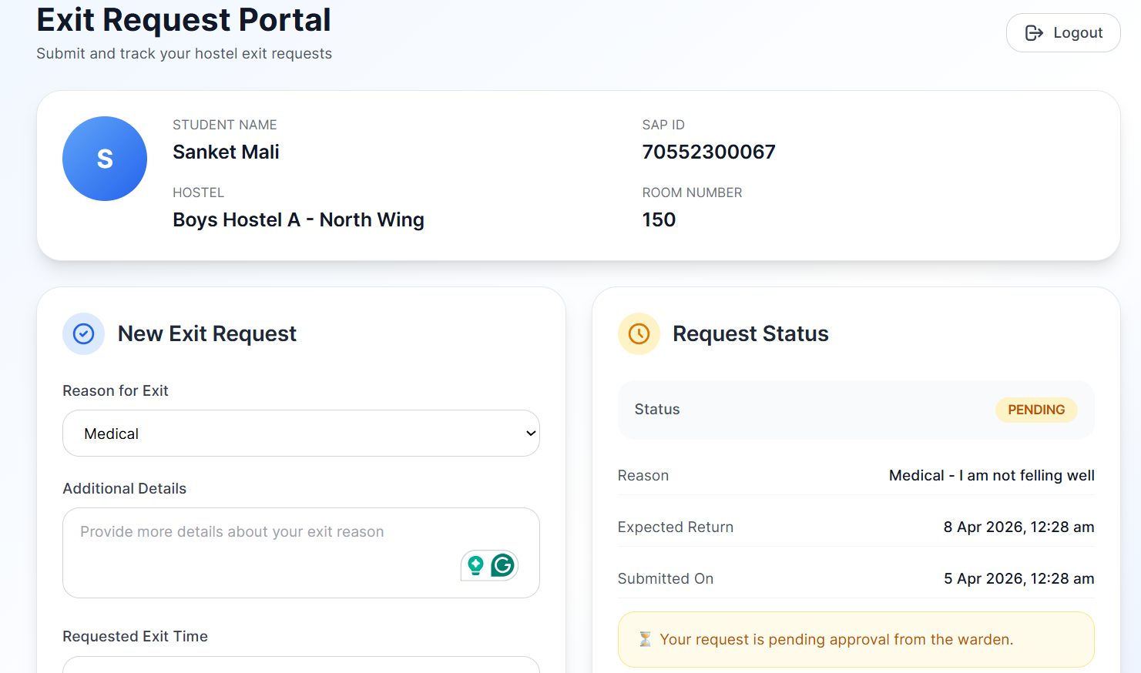
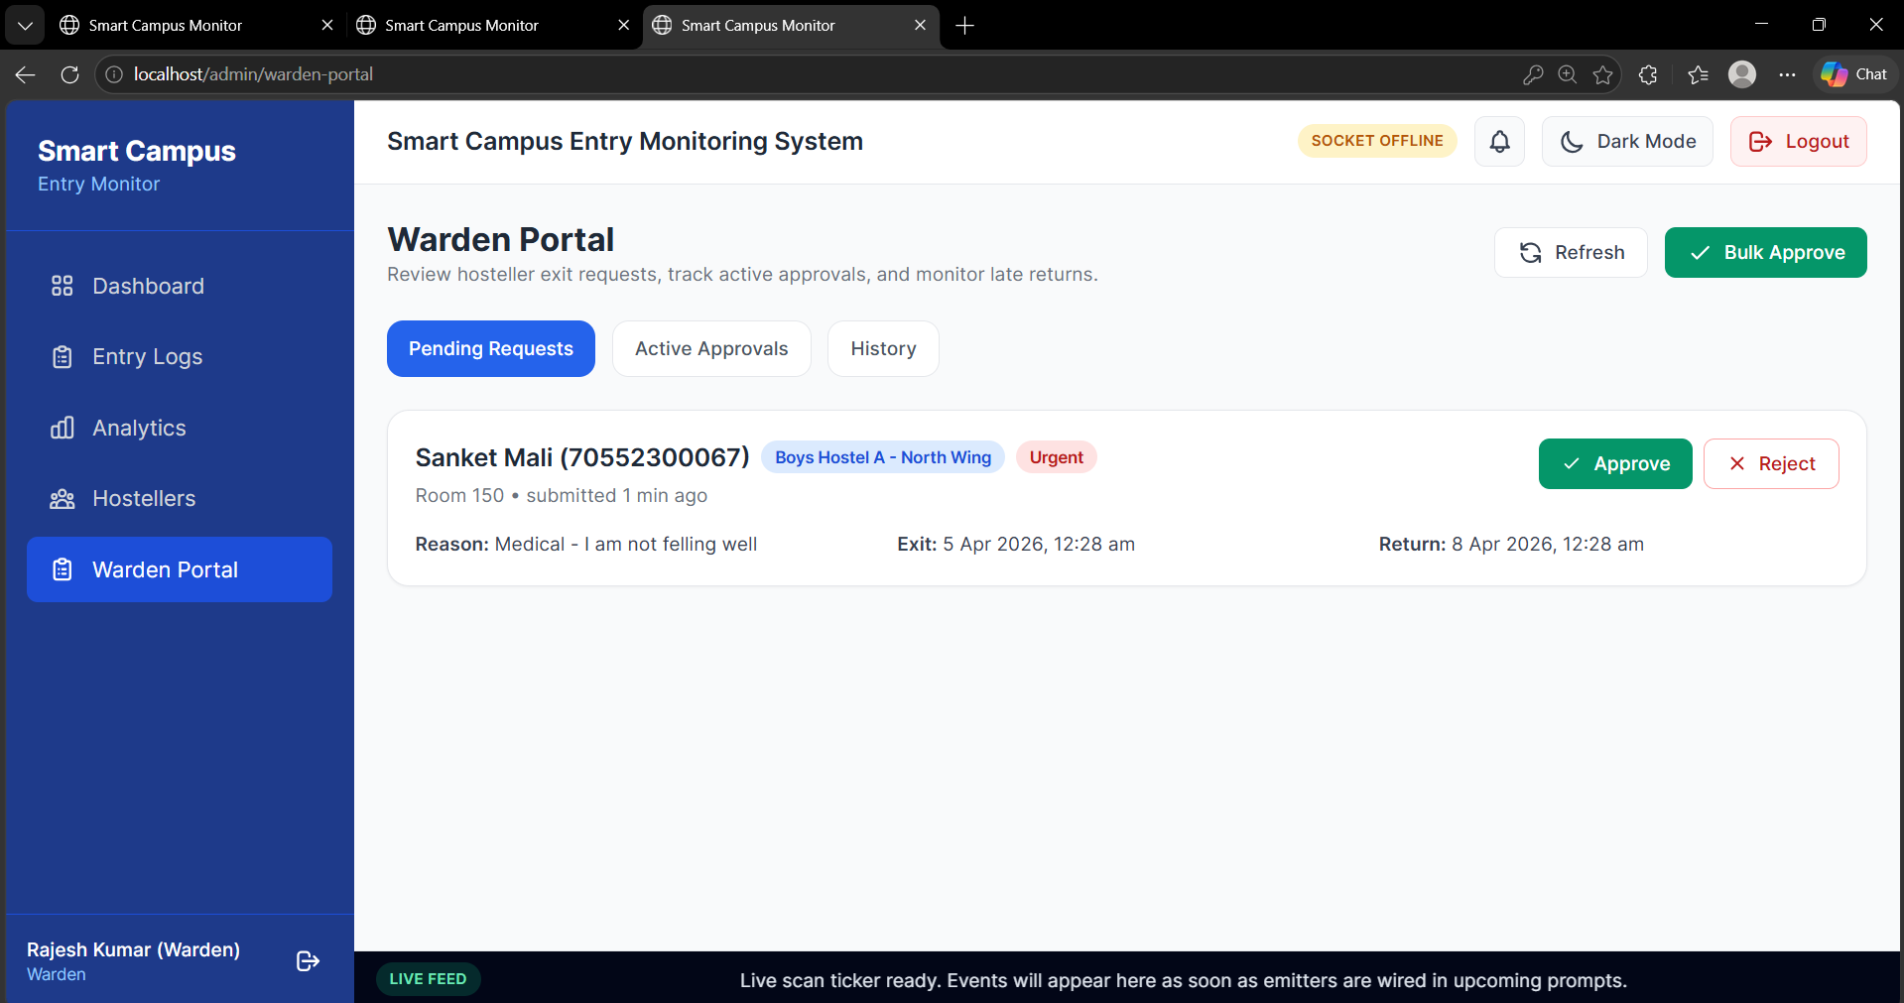
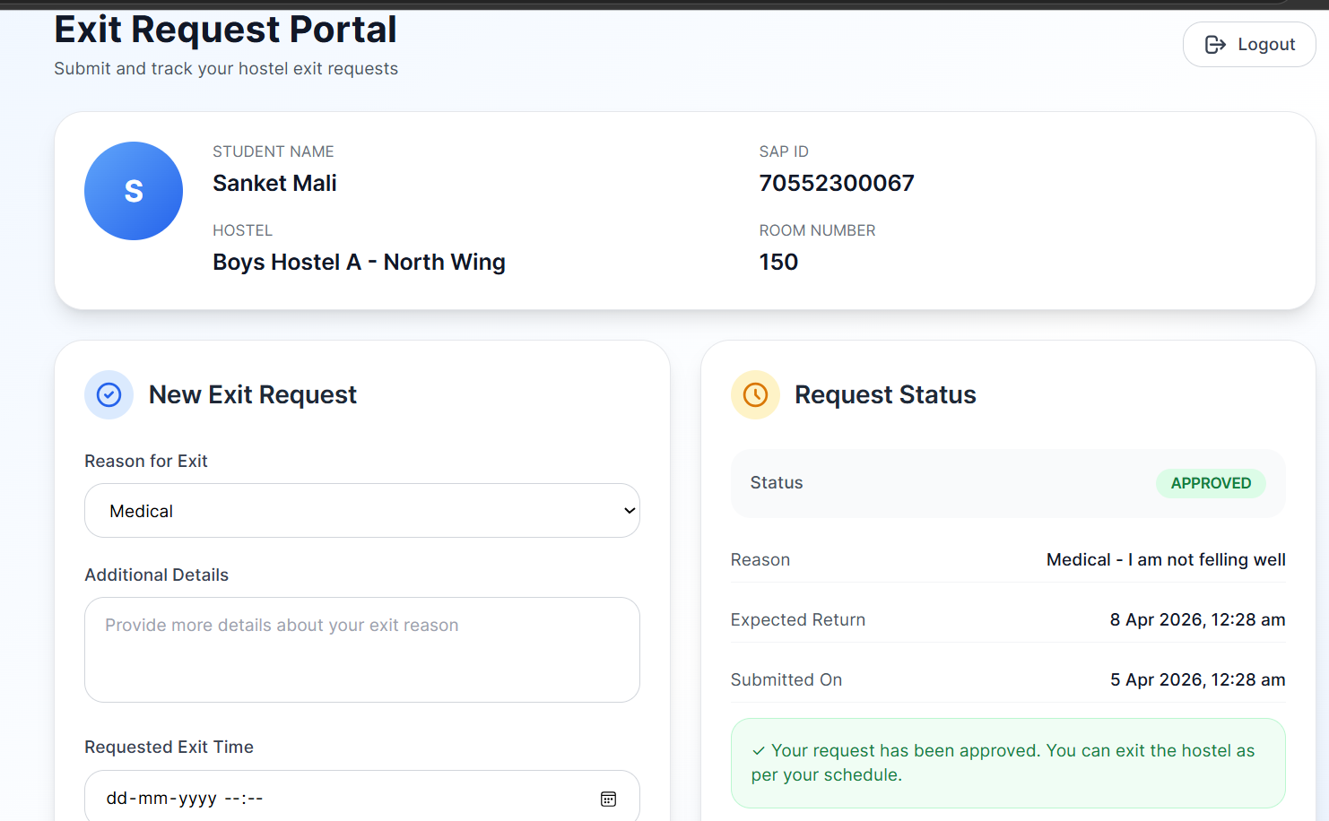
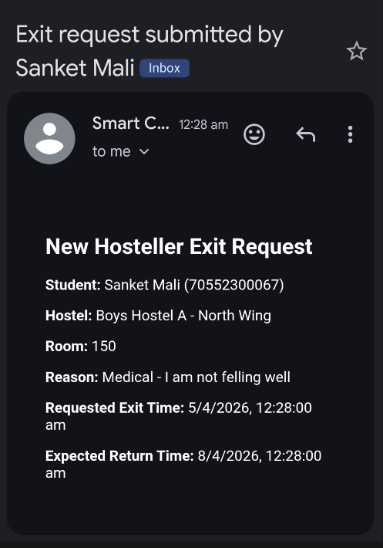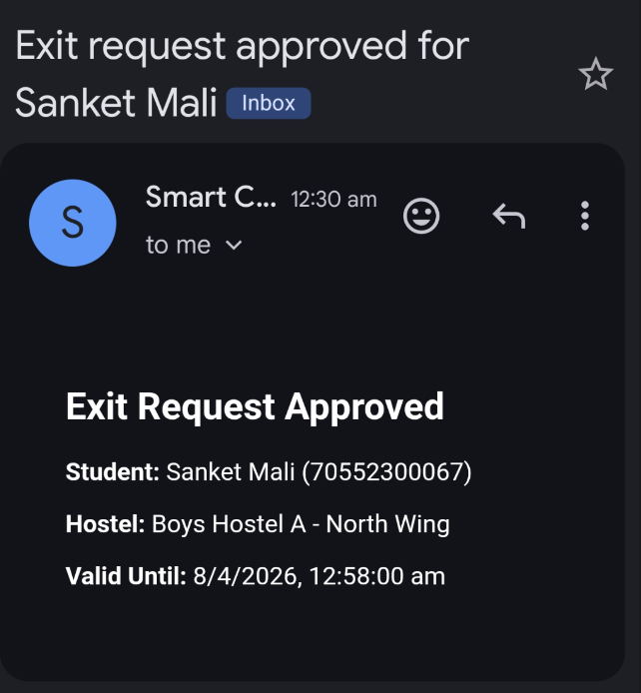

20. Conclusion and Approval Request
"This system transforms the campus into a secure, smart, and digitally monitored environment — improving safety, efficiency, and transparency for students, parents, wardens, and administration alike."

The Smart Campus Entry Monitoring and Biometric Access Control System is a production-ready, fully engineered solution built specifically for SVKM's NMIMS MPSTME, Shirpur. It uses industrial-grade biometric hardware trusted by Indian banks and government offices, a proven open-source software stack, and Amazon SES for reliable email delivery — at a one-time hardware cost of ₹41,600 and a recurring cost of just ₹1,800 per month.

The demo pilot demonstrates every feature of the complete system with just two terminals at one gate. Scaling to all campus gates after approval requires only adding more terminals — no architectural change, no new software, no additional server.

The following approvals and support are formally requested:

- Approval to procure hardware items listed in Section 16
- Permission to wall-mount two terminals at the pilot gate with required power sockets
- One LAN cable run from server room to gate switch location
- Access to one college PC for the server (or approval to procure)
- A two-week student enrollment drive window — batch-wise by department
- AWS account creation for Amazon SES (developer handles all configuration)

I am confident this system will significantly improve campus security, reduce the administrative burden on security staff, and give parents the real-time transparency they deserve.
Submitted by:
Sanket Mali
B.Tech Computer Science — 2023–2027
SVKM's NMIMS MPSTME, Shirpur
IEEE Published Researcher (DELCON 2025) | AWS Certified | Full-Stack Developer

